**Final Assignment**

Problem Statement:

Description:

1. Create a table called Cars with the following fields:

S_no varchar (6)

Name varchar (15)

Model varchar (15)

Year varchar (15)

Price varchar (20).

Category_categoryId INT;

Store_storeId INT;

1. Create a table called category with the following fields:

categoryId INT;

Name varchar(20);

Discription varchar(20);

1. Create a table called store with the following fields:

storeId INT;

Name varchar(20);

City varchar(20);

1. Insert the 5 records to all the tables and assign primary key for the tables.

Done

1. Display the all the records from the car table.

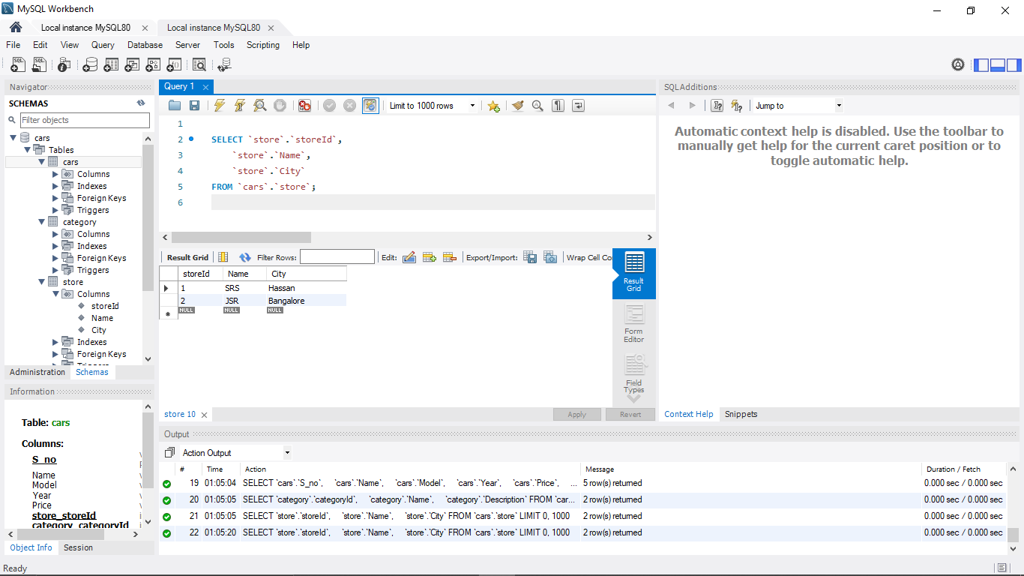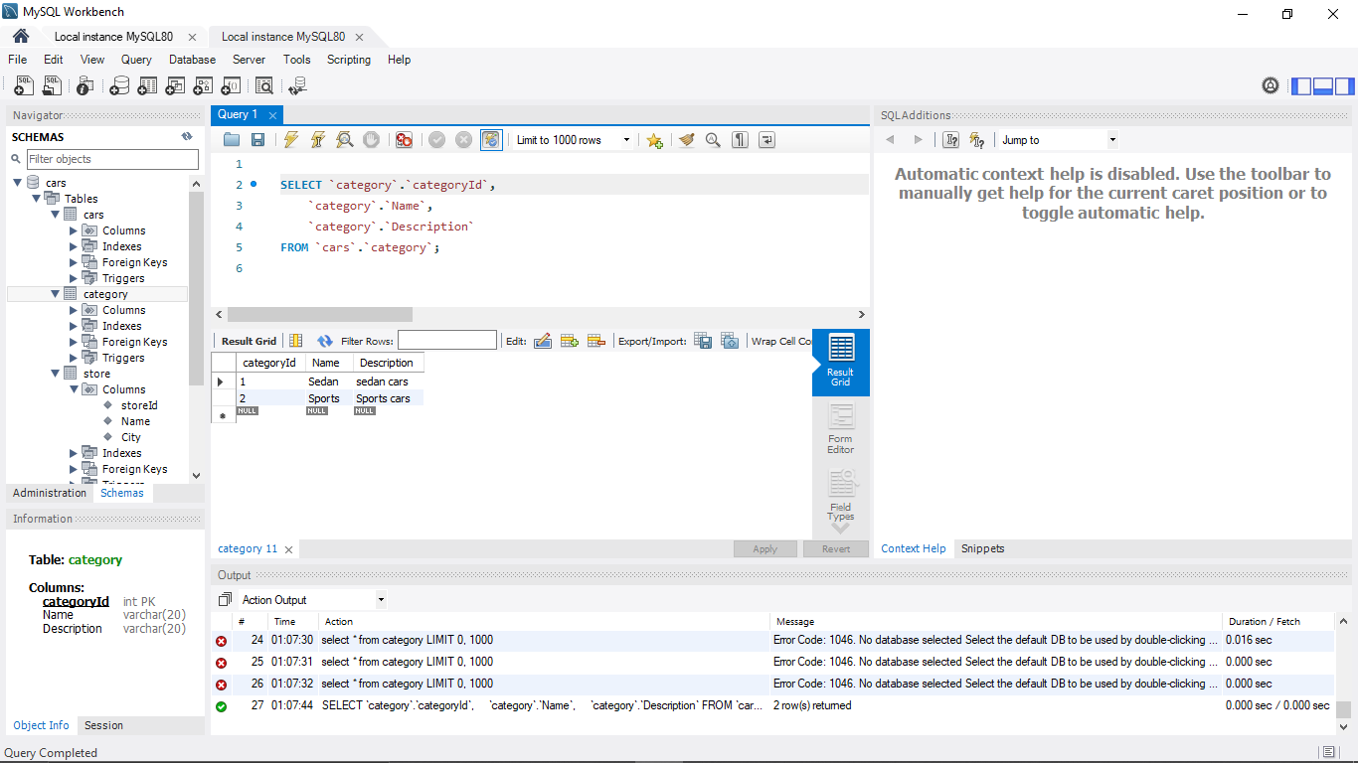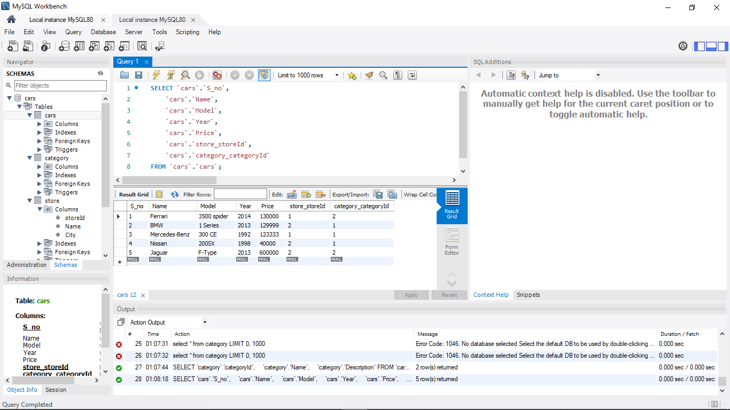

1. Perform one-to-one relationship for any columns of cars and category tables.

Done

1. Perform one-to-many relationship for any of your choice columns in the above table.

Done

